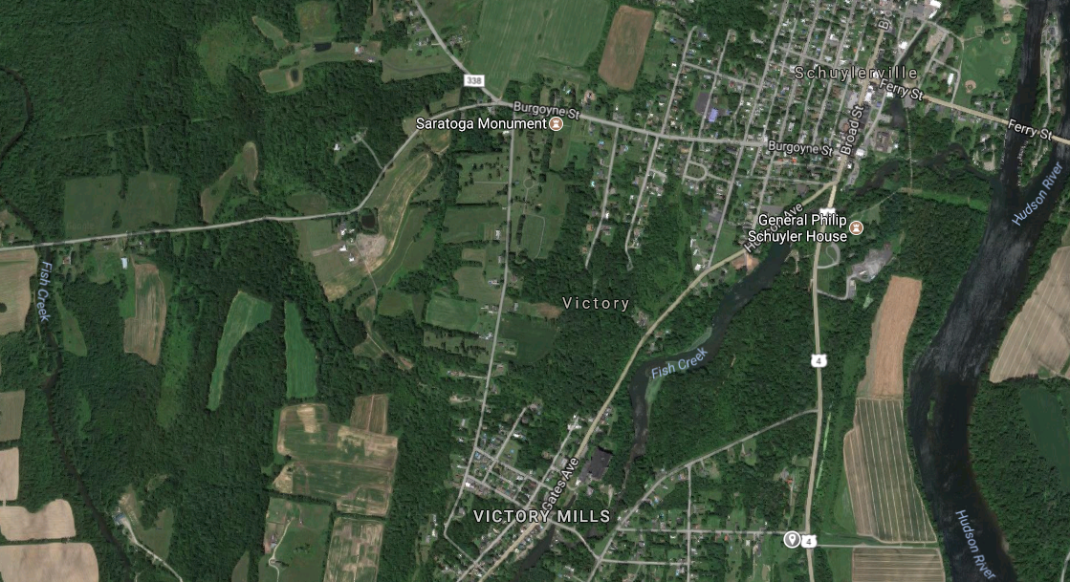

❹ Visitor Center

❾ Breymann Redoubt and Arnold Memorial

Great Redoubt, Burgoyne Headquarters
❺ Freeman’s Farm and Fraser Burial Site
❽ Balcarres Redoubt ❿

❼ Fraser’s Fatal Shooting

❻ Barber Wheatfield

❷ Neilson Farm

American Camp

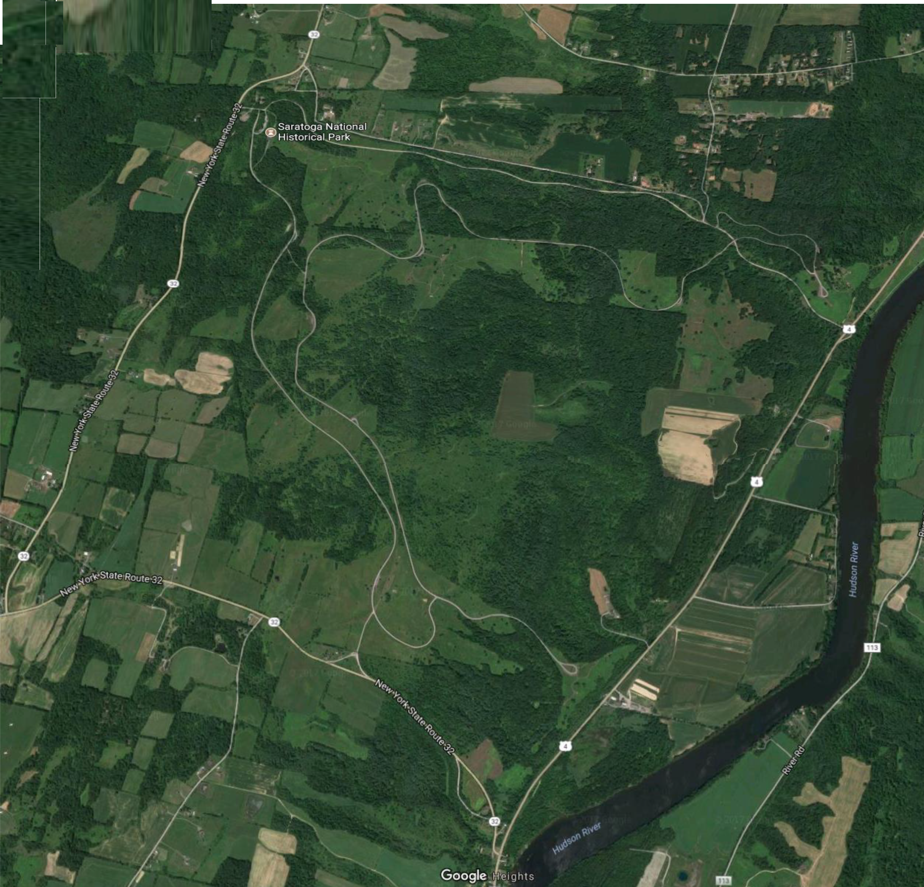
❶ Gates Headquarters ❸ American River Fortification

