The Great Patriot Trail of 1777
August 23 to August 25, 2017

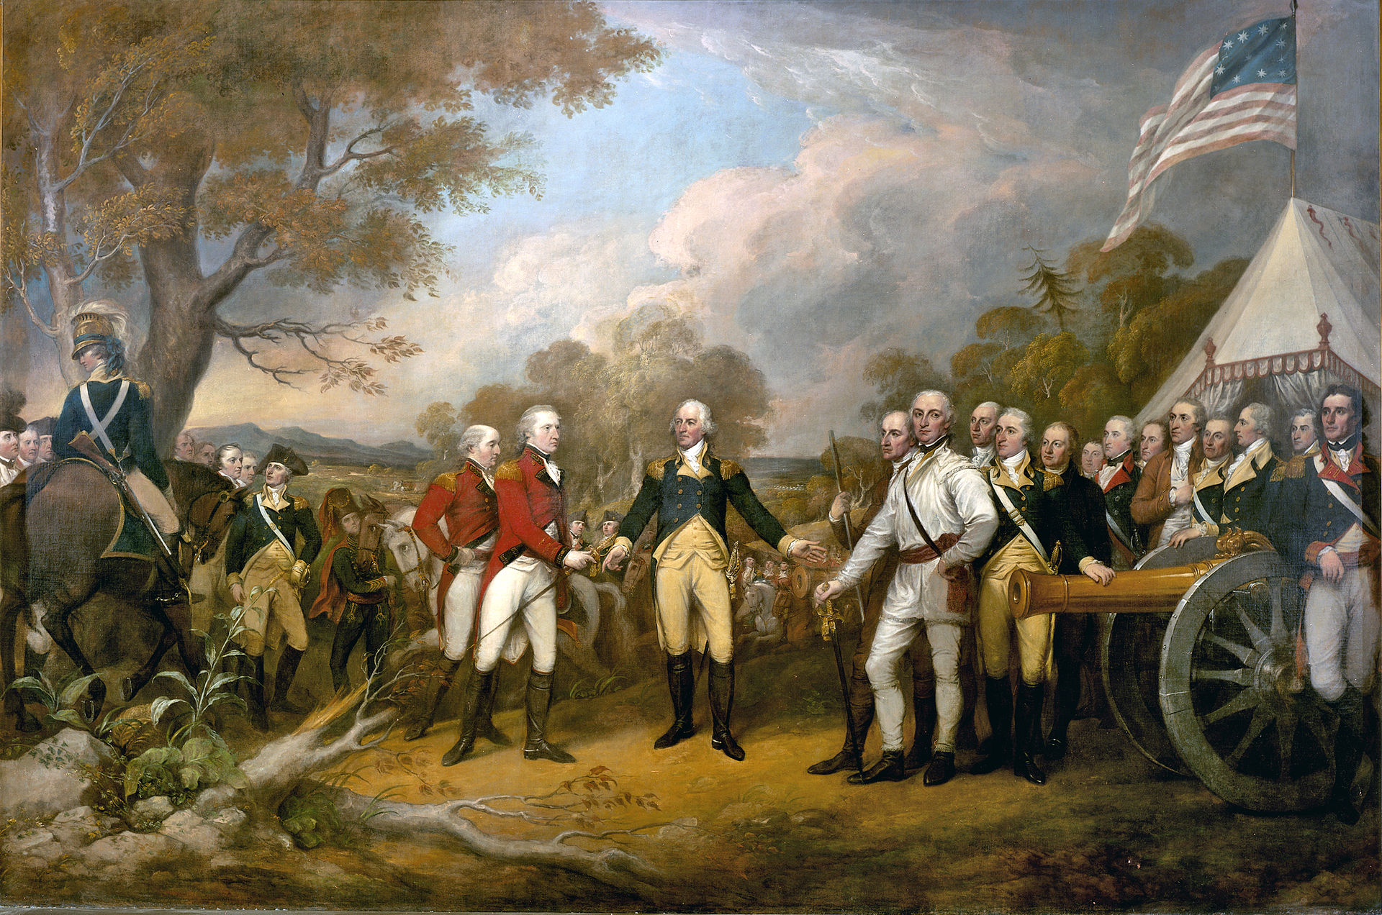

A Prelude Tour to “Freedom’s Gateway:
How the Empire State Created America
and Delivered upon the Promise of Liberty.”

Robert T. Farley
Author / Guide

Mark Gardner
Historian / Adventurer

