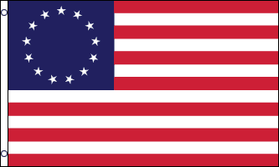

**The Great Patriot Trail of 1777**

**A Prelude Tour to: *Freedom’s Gateway:***

**How the Empire State Created America and Delivered Upon the Promise of Liberty**