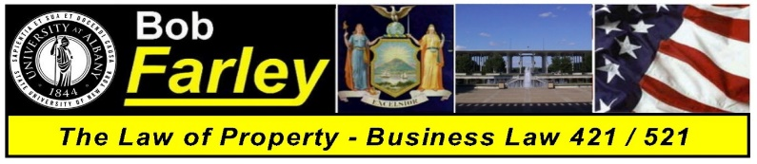

Professor Robert Farley
BLAW 421 / 521 – Law of Property - Class Schedule
Thursdays: 5:45PM to 8:35PM - Lecture Center 20

Class One | August 30, 2018  Slide Set 01, Exercise 01 | Introduction - Course Overview - Audio cla01  The Law and the Importance of Property
Class Two | September 6, 2018 | No Class  Please Have a Safe and Enjoyable Time – See You Next Week
Class Three | September 13, 2018  Slide Set 02, Case 01 | An Introduction to the Law - Audio cla02  The History of American Law and Nature of Property Rights
Class Four | September 20, 2018  Slide Set 03, Case 02 | The Law of Property - Audio cla03  An Explanation of Terms and the Four Postulates
Class Five | September 27, 2018  Slide Set 04, Case 03 | Personal Property One - Audio cla04  Property Rights and the Acquisition of Title
Class Six | October 4, 2018  Slide Sets 05 – 07, Case 04 | Personal Property Two - Audio cla05  Gifts, Liens, Bailments and Special Property Interests
Class Seven | October 11, 2018  Slide Sets 09 – 10, Case 05 | Intellectual Property and The Criminal Law - - Audio cla06  Patents, Trademarks & Copyrights / The Common Law Felonies
Class Eight | October 18, 2018  MidtermReviewSlides(pdf) | Midterm Exam
Class Nine | October 25, 2018  Slide Sets 11 – 13, Case 06 | Real Property One - Audio cla07  Definition of Terms, Real Property Taxes, Shared Rights in Land
Class Ten | November 1, 2018  Slide Sets 14 – 16, Case 07 | Real Property Two - Audio cla08  Estates in Land, Future Interests and Title Limitation Rules
Class Eleven | November 8, 2018  Slide Sets 17 – 19, Case 08 | Real Property Three - Audio cla09  Non Possessory Interests, Fixtures and Adverse Possession
Class Twelve | November 15, 2018  Slide Set 20, Exercise 03 | Real Property Four - Audio cla10  Conveyances and Security Interests – Buying / Selling Real Property
Class Thirteen | November 22, 2018 | Thanksgiving  Please Have a Safe and Enjoyable Time with Your Family and Friends
Class Fourteen | November 29, 2018  Slide Sets 21 - 23, Case 09 | Real Property Five - Audio cla11  Nuisance, Trespass, Zoning and Eminent Domain / Condemnation
Class Fifteen | December 6, 2018  Slide Set 24 | Real Property Six - Audio cla02  Leasehold Interests, Landlords and Tenants
Review Class  (Optional) | December 8, 2018  Final Review Slides (pdf) | Final Exam Review Class  Comprehensive – Entire Class Review
Final Exam | December 13, 2018 | Final Exam
* * * This Schedule is Subject to Revision as Class Progresses ***

