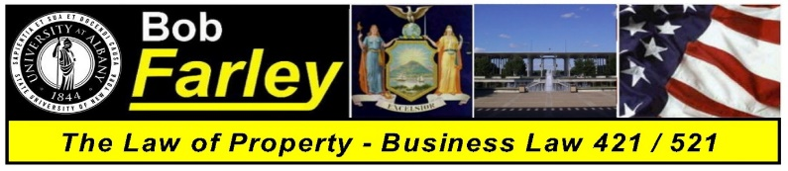

Professor Robert Farley
BLAW 421 / 521 – Law of Property – Case / Exercise List
Thursdays: 5:45PM to 8:35PM - Lecture Center 20

Slide Set 01 | Introduction - Course Overview  The Law and the Importance of Property | Exercise 01 | How a Bill Becomes a Law
Slide Set 02 | An Introduction to the Law  The History of American Law and Nature of Property Rights | Case 01 | Marbury v. Madison
Slide Set 03 | The Law of Property  An Explanation of Terms and the Four Postulates | Case 02 | Dred Scott v. Sandford
Slide Set 04 | Personal Property One  Property Rights and the Acquisition of Title | Case 03 | Pearson v. Post
Slide Set 05 | Personal Property Two  Gifts | Case 04 | Gruen v. Gruen
Slide Set 06 | Personal Property Two  Liens
Slide Set 07 | Personal Property Two  Bailments and Special Property Interests
Slide Set 08 | Constitutional Law  The Development and Meaning of Legal Protections | Exercise 02 | Constitutional Conventions
Slide Set 09 | Intellectual Property  Patents, Trademarks and Copyrights | Case 05 | Regina v. Dudley and Stephens
Slide Set 10 | The Criminal Law  Criminal Procedure and Common Law Felonies
Midterm Set | Midterm Exam
Slide Set 11 | Real Property One  Definition of Terms | Case 06 | McCulloch v. Maryland
Slide Set 12 | Real Property One  Real Property Taxes
Slide Set 13 | Real Property One  Shared Rights in Land
Slide Set 14 | Real Property Two  Estates in Land | Case 07 | In Re Susannah North
Slide Set 15 | Real Property Two  Estates in Land
Slide Set 16 | Real Property Two  Title Limitation Rules
Slide Set 17 | Real Property Three  Non Possessory Interests | Case 08 | Red Hill Outing Club v. Hammond
Slide Set 18 | Real Property Three  Fixtures
Slide Set 19 | Real Property Three  Adverse Possession
Slide Set 20 | Real Property Four  Conveyances and Security Interests | Exercise 03 | Who Wants to Be a Homeowner
Slide Set 21 | Real Property Five  Trespass | Case 09 | Kelo v. City of New London
Slide Set 22 | Real Property Five  Zoning
Slide Set 23 | Real Property Five  Eminent Domain / Condemnation
Slide Set 24 | Real Property Six  Leasehold Interests, Landlords and Tenants
Final Set | Final Exam Review Class  Comprehensive – Entire Class Review

