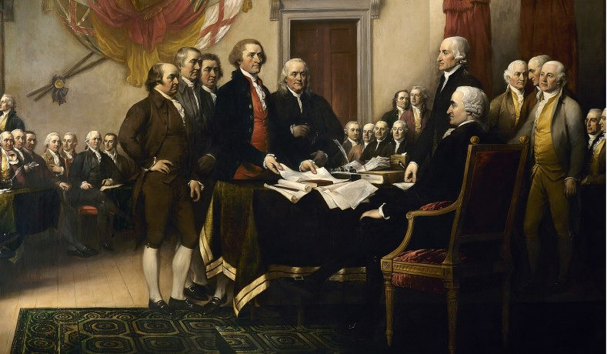
Declaration of Independence
In Congress, July 4, 1776
Philadelphia

