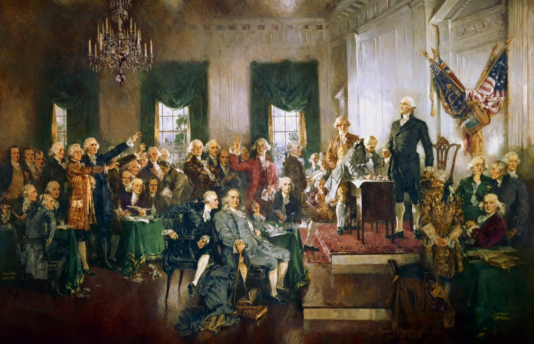
United States Constitution
In Convention, September 17, 1787
Philadelphia

