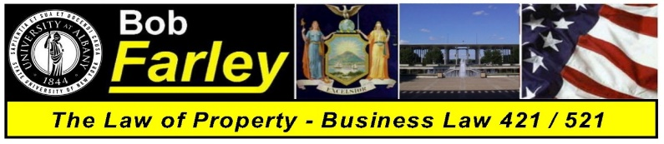

Class Attendance List Date: ___________________

No. | Student # | Student Name | Major / Minor | Year | Attendance
1 | 001302864 | Saujay Adams (Saw Jay) | Business Administration / Accounting/Business (Minor) | Junior
2 | 001293052 | Aaron Alli | Economics / Business (Minor) | Senior
3 | 001347608 | Sierra Chalmers | Criminal Justice (intended) / Business - Sociology (Minor) | Junior
4 | 001324713 | Andrew Dachinger | Criminal Justice / EmerPrep,HomeldSec&Cybsec (Minor) | Junior
5 | 001255298 | Joseph Dipalma | Sociology / Business (Minor) | Senior
6 | 001303489 | Justin Dixon | Economics / Business (Minor) | Senior
7 | 001345657 | Jennesis Escoboza (Genesis) | Business Administration / Sociology (Minor) | Junior
8 | 001371788 | Adriana Fernandez (A Dree Anna) | Economics / Business (Minor) | Senior
9 | 001317020 | Alexander Fielding | Criminal Justice / Philosophy (Minor) | Junior
10 | 001313900 | Gideon Fosu | Economics / Business (Minor) | Junior
11 | 001250930 | Amanda Gallo | Forensic Accounting | Graduate
12 | 001274983 | Alicia Gazzillo | Economics / Business (Minor) | Junior
13 | 001337558 | Matthew Grugnale | Economics / Business (Minor) | Junior
14 | 001260698 | Livia Hendrickson | Digital Forensics / Business EmerPrep,HomeldSec&Cybsec (Minor) | Senior
15 | 001276446 | Ryan Horan | History / Business (Minor) | Senior
16 | 001286936 | Thomas Hulbert | Economics / Business (Minor) | Senior
17 | 001282810 | Yungyoung Jo (Jo) | Forensic Accounting | Graduate
18 | 001299307 | Christein Joseph (Kristian) | College of Arts and Sciences / Biology - Business (Minor) | Senior
19 | 001365351 | James Kan | Business Administration | Graduate
20 | 001281858 | Demetri Koutsidis | Economics / Business (Minor) Mathematics (Minor) | Senior
21 | 001281858 | Matt Kranz | EmergPrep,HomelandSec&Cybsec / Business (Minor) | Senior
22 | 001347988 | Marisa Locastro | Business Administration / Accounting - Business (Minor) | Junior
23 | 001226044 | Michael May | Business Administration | Graduate
24 | 001019697 | Kathleen McCarthy | Business Administration | Graduate
25 | 001407287 | Erik Medina | Accounting / Business Administration (Minor) | Junior
26 | 001372893 | Brian Morcerf | Business Administration – Undeclared (Minor) | Junior
27 | 001291057 | Apphia Nurse (Aff Fee Ahh) | Public Affairs / Political Science - Spanish (Minor) | Senior
28 | 001308253 | Victoria Okraszewski | Public Affairs / Political Science - Business (Minor) | Senior
29 | 001317838 | Carina Ogievich | Forensic Accounting | Graduate
30 | 001263959 | Prince Okyere | Business Administration | Graduate
31 | 001297951 | Michael Paralikas | Economics / Business (Minor) | Senior
32 | 001106098 | Kyle Pentak | Economics / Business (Minor) | Junior
33 | 001254793 | Jack Prew-Estes | Business Administration – Undeclared (Minor) | Senior
34 | 001023292 | Joe Ronolder | Business Administration | Graduate
35 | 000961344 | Tom Rood | Business Administration | Graduate
36 | 001289075 | Zachary Rubinchik | Economics / Business (Minor) | Junior
37 | 001311770 | Anthony Sacramone | Economics / Business (Minor) | Junior
38 | 001283577 | Natalie Santos | Business Administration / Accounting - Business (Minor) | Senior
39 | 001305982 | Abolaji Soyemi (Ab Bow Laj Eee) | Business Administration | Graduate
40 | 001341427 | Matthew Stanton | Biology / Psychology (Minor) | Senior
41 | 001365350 | Fei Teng | Business Administration | Graduate
42 | 001407151 | Thu Vu | Business Administration – Accounting - Business (Minor) | Senior
43 | 001250056 | Andy Wu | College of Arts and Sciences / Economics - Business (Minor) | Senior
44 | 001407884 | Tyler Wutzke | Business Administration / Accounting/Business (Minor) | Senior

