

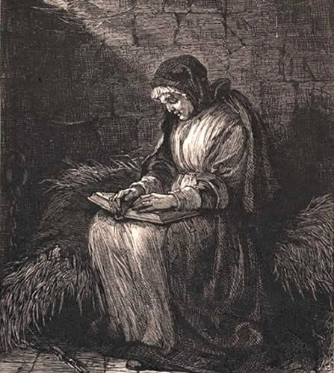
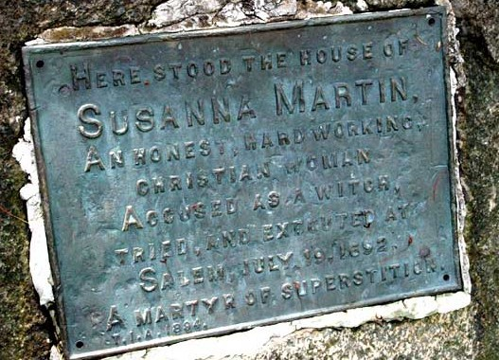
Crown v. Susannah North Martin
Court of the County of Essex, Colony of Massachusetts Salem, Year of Our Lord 1692

Case Description and Brief

Susannah Martin was born in Buckinghamshire, England in 1621.
She was the fourth daughter, and youngest child, of Richard North and Joan (Bartram) North.
Her mother died when she was a young child, and her father remarried a woman named Ursula Scott.
In 1639, at the age of 18, Susannah and her family came to the United States, settling in Salisbury, Massachusetts. Richard North, a highly respected man, was listed as one of the first proprietors and founders of Salisbury
On August 11, 1646, Susannah, now 24, married the widower George Martin, a blacksmith.
Making their home in Salisbury, the couple had a loving marriage, that produced nine children, one of which died in infancy. Prosperous in business, George and Susannah became one of the largest landholders of the region.
George died in 1686, leaving Susannah a widow.
After her husband’s death she managed his estate and lands with acumen and talent.
As a young woman she was known for her exceptional beauty. Descriptions of Susanna say that she was short, active, and of remarkable personal neatness. She was also said to be very outspoken, contemptuous of authority, and defiant in the face of challenge. Due to her attractiveness and family’s prosperity, she had been the target of jealous slander, which had followed her for years, all of which had been proven unfounded.

In January 1692, a a group of young girls began to display bizarre behavior in nearby Salem, Massachusetts. The tight-knit community was at a loss to explain the convulsive seizures, blasphemous screaming, and trance-like states that afflicted the youngsters. The physicians called in to examine the girls could find no natural cause of the disturbing behavior. If the source of the affliction was not attributable to a physical malady, the community reasoned that it must be the work of Satan. Witches, they figured, had invaded Salem.
In February the village began praying and fasting in order to rid itself of the devil's influence. The girls were pressured to reveal who in the community controlled their behavior. Three women were identified and examined. One, Tituba (a slave), confessed to seeing the devil who appeared to her "sometimes like a hog and sometimes like a great dog." Even more troubling, Tituba confessed that a conspiracy of witches permeated Salem Village.
In March the afflicted girls accused Martha Corey. The three women previously denounced as colluding with the devil were marginal to the community. Martha Corey, however, was different; she was an upstanding member of the Puritan congregation - her revelation as a witch demonstrated that Satan's influence reached to the very core of the community.
Events then snowballed as the accusatory atmosphere intensified and reached a fever pitch.
During the period from March into the fall many were charged, examined, tried and condemned to death. The hangings started in June with the death of Bridget Bishop and continued through September.
On April 30, 1692 a warrant was issued for Susannah's arrest on a charge of witchcraft.
Inhabitants of nearby Salem Village, Massachusetts had named Susannah a witch and stated she had attempted to recruit them into witchcraft.
She was arrested on May 2, 1692.

"When she saw Orlando Bagley (the Amesbury Constable) approaching on the morning of her arrest, little did she dream of his errand. He was a personal friend of long standing, and we can but faintly imagine her surprise when..." he read the warrant. Bagley then escorted Susannah the 20 miles to Salem Village.

The Case of Susannah North Martin Page 2
During her preliminary examination the same day, Susannah vigorously answered the charges against her.
Taken by complete surprise, Susannah could not fathom the absurdity of the charges. When the " afflicted girls" began having fits, she laughed out loud. When the magistrates asked why she laughed, she responded, "Well I may at such folly."

The principle reason for her accusal, however, may well have had nothing to do with witchcraft of fears over it. Indeed it may well have been motivated by both jealousy and greed. Although, both English and Massachusetts law did not expressly provide for land forfeiture upon a capital conviction, George Corwin, the Sheriff of Essex Country and son of the local magistrate (who was the examiner (prosecutor) and judge of the witch trials), and a man whose salary was paid by commission, cited a long standing precedent for such forfeiture of all lands by those convicted of witchcraft, and seized the property of many of those arrested. Declaring their lands and property as escheating to the state, Corwin personally benefitted from this seizure as did his father Jonathan Corwin, Thomas Putnam and another judge John Hawthorne.
Susannah was tried for these charges, during which she proved by all accounts to be pious, quoting the Bible freely, something a witch was said to be incapable of doing.

The Rev. Cotton Mather, recorder of testimony and local Puritan minister, was one of the primary forces behind the witchcraft trials, held a substantial bias against Susannah, and her views as a strong, successful and prosperous woman, said:

"This woman was one of the most impudent, scurrilous, wicked creatures of this world; and she did now throughout her whole trial discover herself to be such a one. Yet when she was asked what she had to say for herself, her chief plea was that she had led a most virtuous and holy life." He further went onto say that she was putting on a show of perfect innocence and Godliness
Joseph Merrill, in his History of Amesbury, however, described Susannah quite differently:
"The idea of snatching this hardworking, honest woman from her home to be tried for her life by those who never knew her, and witnesses who were prejudiced against her. is almost too much for belief. Allowed no counsel, she was her own lawyer, and her answers are remarkable for independence and calmness. She showed herself to be a woman of more than ordinary talent and resolution."

During this time Susannah, now a 71 year old grandmother, was forced to undergo the mental anguish and suffering of the two and a half months in a Salem jail. “The conditions were beyond our power of description”, indicated a contemporary.

On June 2, 1692, during her incarceration, Susannah was forced to undergo the indignity of multiple physical examinations. These examinations were intended to discover whether the accused had any physical abnormalities. At no examination was any abnormality discovered, but at the first her breasts appeared to be full and at the second slack. The magistrates found this apparent indication that she had been visited by a witch's familiar, and they argued was clear evidence of her guilt.
On June 26, 1692 her trial began. Susannah had pleaded not guilty, was denied counsel, and proceeded to trial.
During her trial Susanna refused to express any thoughts on what may have ailed the girls but bluntly stated that she didn't think they were bewitched. Her further testimony declared that she realized the seriousness of her situation and she adamantly maintained her innocence. The court presumed her guilt, and the judge acted as both court and prosecutor.

Spectral evidence was a key in the prosecution, in the joint trial of Susannah Martin, Sarah Good, Rebecca Nurse, Sarah Wilde, and Elizabeth Howe. On June 30, 1692, the five women were convicted and sentenced to be hanged.

While awaiting execution, and during their incarceration, Susannah Martin was described as a loving, comfort to the four young women who had been convicted with her, being described as a “fountain of Christian faith and kindness”. Each day she would pray and offer words of support and consolation to the other young women.

On Tuesday, July 19, 1692 Susannah Martin, and the other four young women were taken from their cells, put into a cart, and driven up the rocky road to Gallows Hill. There they were executed by hanging, and their bodies were thrust into a shallow grave in a crevice of felsite.

In 1711, the General Court of Massachusetts granted compensation to many of the victims or their heirs of the Salem witch trials. Susannah's children, however, made no application to the authorities and consequently received no remuneration. As a result, Susannah was not among those whose attainder was lifted.
Over three hundred years after her wrongful conviction, however, on October 31, 2001, after decades of protests, then acting governor of Massachusetts, Jane Swift, signed into law, a bill which formally and officially pardoned Susannah North Martin.

