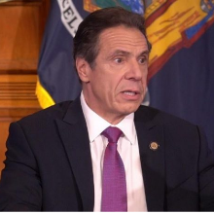

Governor Andrew Cuomo
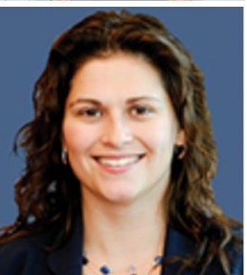
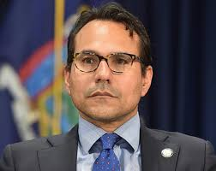
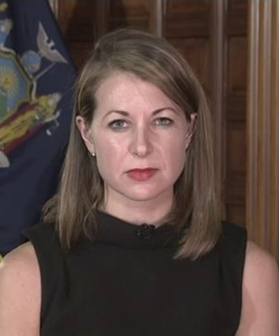
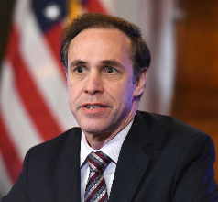
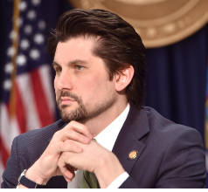

Dr. James Malatras Dr. Howard Zucker Elizabeth Garvey Melissa DeRossa Robert Mujica
President Commissioner Counsel to Secretary to Director
Empire State College NYS Dept of Health Governor Cuomo Governor Cuomo NYS Div. of Budget

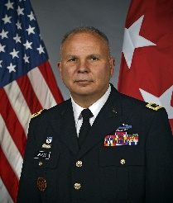
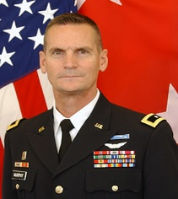

Gen. Patrick Murphy Gen. Raymond Shields, Jr.
Commissioner Adjutant General
NYS Div. Homeland Security NYS Div. Military and Naval
and Emergency Services Affairs – NY Army Nat’l Guard

