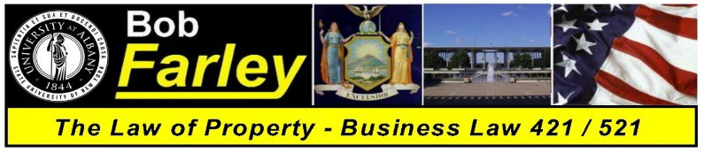
Professor Robert Farley
BLAW 421 / 521 – Law of Property - Class Schedule

Class One | Slide Set 01  Class Lecture Video 01 | Introduction - Course Overview  The Law and the Importance of Property
Class Two | Slide Set 02  Class Lecture Video 02 | An Introduction to the Law  The History of American Law and Nature of Property Rights
Class Three | Slide Set 03  Class Lecture Video 03 | The Law of Property  An Explanation of Terms and the Four Postulates
Class Four | Slide Set 04  Class Lecture Video 04 | Personal Property One  Property Rights and the Acquisition of Title
Class Five | Slide Set 05  Class Lecture Video 05 | Personal Property Two  Gifts
Class Six | Slide Set 06  Class Lecture Video 06 | Personal Property Three  Liens, Bailments and Special Property Interests
Class Seven | Slide Set 07  Class Lecture Video 07 | Intellectual Property  Patents, Trademarks & Copyrights
Class Eight | Slide Set 08  Class Lecture Video 08 | The Criminal Law  Principles of Criminal Law / The Common Law Felonies
Midterm | Midterm Review Slide Set | Midterm Exam
Class Nine | Slide Set 09  Class Lecture Video 09 | Real Property One  Definition of Terms, Real Property Taxes, Shared Rights in Land
Class Ten | Slide Set 10  Class Lecture Video 10 | Real Property Two  Estates in Land, Future Interests and Title Limitation Rules
Class Eleven | Slide Set 11  Class Lecture Video 11 | Real Property Three  Non Possessory Interests, Fixtures and Adverse Possession
Class Twelve | Slide Set 12  Class Lecture Video 12 | Real Property Four  Conveyances and Security Interests – Buying / Selling Real Property
Class Thirteen | Slide Set 13  Class Lecture Video 13 | Real Property Five  Trespass, Zoning and Eminent Domain / Condemnation
Class Fourteen | Slide Set 14  Class Lecture Video 14 | Real Property Six  Leasehold Interests, Landlords and Tenants
Class Fifteen | Slide Set 15  Class Lecture Video 15 | Final Exam Review Class  Comprehensive – Entire Class Review
Final Exam | December 5, 2019 | Final Exam

* * * This Schedule is Subject to Revision as Class Progresses ***

