Prelude

Above the map, north of Gettysburg, ROBERT E. LEE’s Army of Northern Virginia is spread across more than twenty-five miles of Pennsylvania farmland. Below the map, GEORGE MEADE’s Army of the Potomac covers a similar swath of southernmost Pennsylvania and northern Maryland:
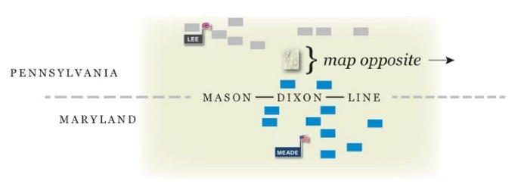

The Union army is larger and better equipped. Weighing morale, generalship, and the string of Confederate victories to date, the match is even. ROBERT LEE needs no introduction. GEORGE MEADE is new to highest command. Lincoln has been going through generals frustratedly. No one knows what the capable, splenetic MEADE will do.

Each army is unclear on the other’s whereabouts. The Confederates have been in Pennsylvania, menacing Harrisburg and the Industrial North; MEADE has been keeping between them and Washington, D.C. Both feel blindly out with parties of horsemen, antennas of spies, scouts, talkative locals, skirmishers, pickets, and lookouts— the cloaking screens and early-warning-system “eyes and ears” indispensable to any great army in the field.

The day before the Battle of Gettysburg begins, Union cavalry under Buford, patrolling around Gettysburg, hear from the citizenry of a Confederate column northwest of town, up the Chambersburg Pike. Buford explores in that direction and sees some Rebels. Following a brief at-a-distance encounter, possibly without a shot fired, both sides retire amicably, part of the reconnoitering process being to probe, engage (only a little), withdraw, report— no major fighting before top command can garner sufficient info.

On the eve of Day One, Buford’s 2,500-plus dismounted cavalry (brigade commanders Gamble, Devin) are in temporary camp (bivouac) west of town. Pickets (small rifle detachments) and vedettes (lookouts) are flung wide, ringing the area like sensors.

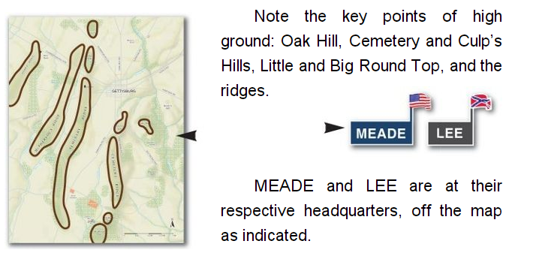

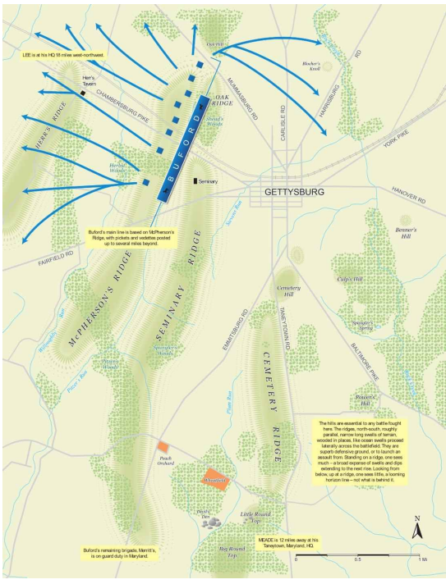

July 1, Early Morning

In the first hours of summer daylight, July 1, 1863, with after-rain steam rising off the farm fields, Confederates exploring in force move southeast down the Chambersburg Pike toward Gettysburg. They encounter Buford’s lookout parties. Misty figures exchange shots.

These forward parties of Buford’s dismounted cavalry are greatly outnumbered. They commence an hours-long, guerrilla-style delaying action, slowing and disrupting the Confederate advance.

The Yankees harry and harass. The Confederate marching columns slow, are blunted, must become cautious— spread some of their number out to either side of the dirt road into adjoining fields and woods to meet the challenge, screen their marching columns from diagonal danger, try to take the fight to the harassing Yankee skirmishers who hide and fire, retreat to new cover on either side of the fenced earthen road, lay down more fire, run again, and then attack from yet again a different angle.

